**Github Repository Link:**

**https://github.com/DisneyJaviya/Python_Practicals.git**

**DICTIONARY**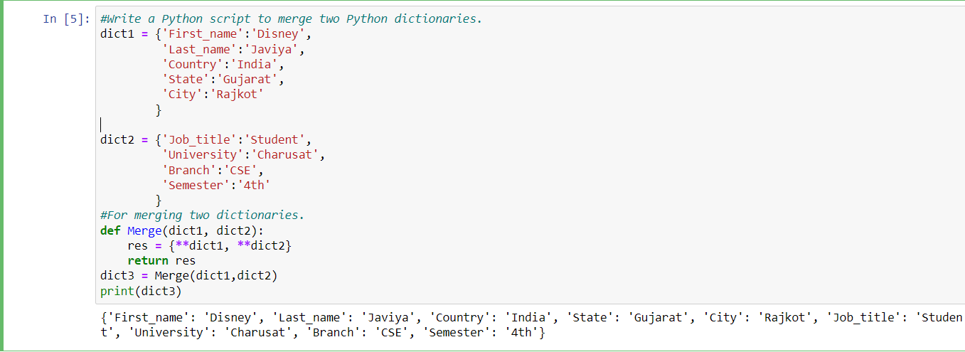

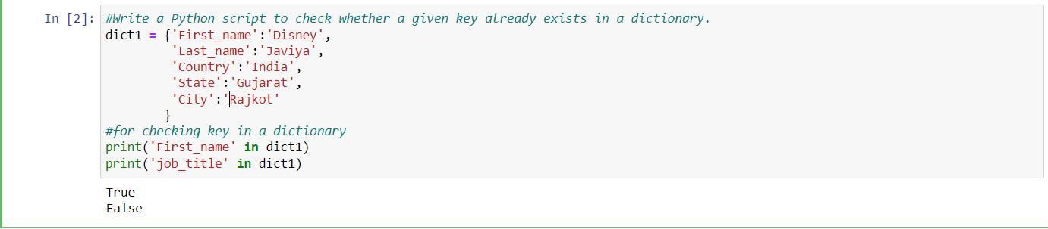

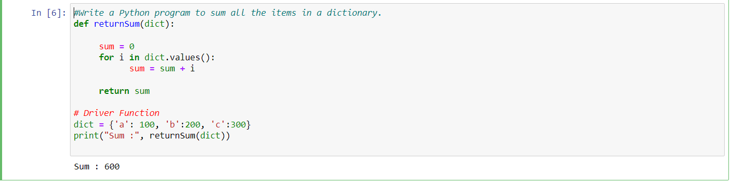

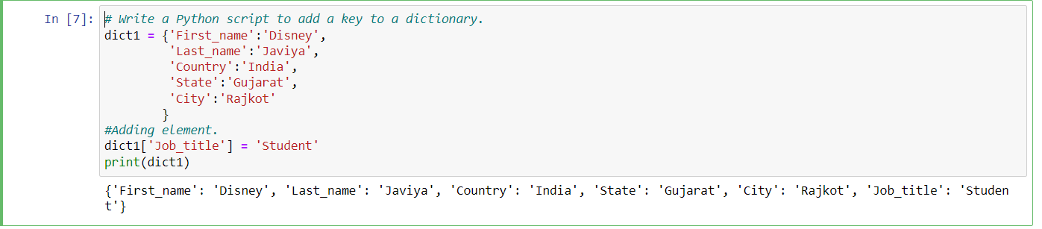

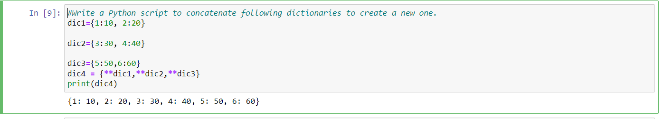

**TUPLE**





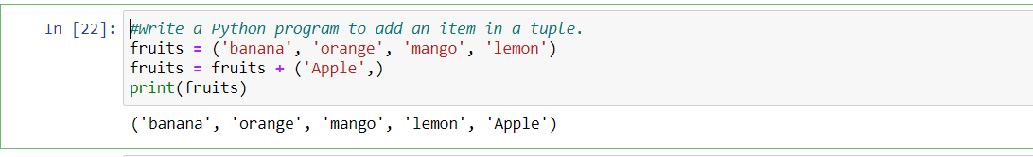

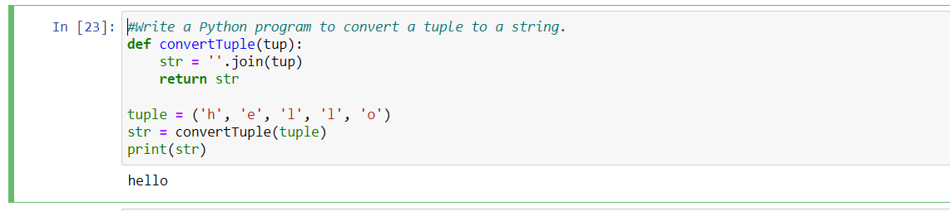

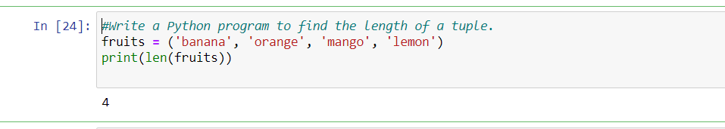

**SET**

